Instructions to Renew SAS

1. Take a deep breath. It will all be over soon.
2. Type “Renew” into your Windows search bar. The “Renew SAS Software” option should populate at the top of the search results. Click on it.
3. You should now see a window asking you for the appropriate SAS installation data file:

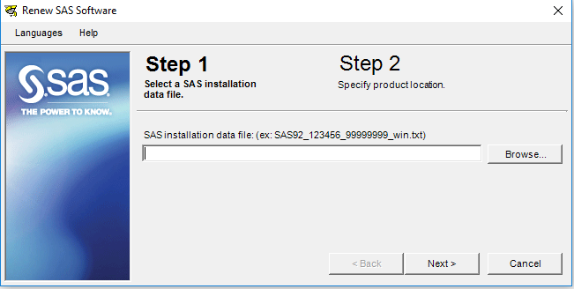

1. Click the “Browse” option.
2. Navigate to \\cs1\Standards\Desktop Software\SAS\SAS 9.4 License Files 2019[1] folder.
3. Select the appropriate text file. Carlos indicated that he just uses the 32-bit version on our PCs. Hence, he selects the file sans “X64” in the title. As an example, here is the title of the file that was used for 2019’s renewal: “SAS94_9C4SSK_70162560_Win_Wrkstn.txt”.
4. You will then click “Next”.
5. The application will then show you a window displaying a list of modules and their new expiration date:

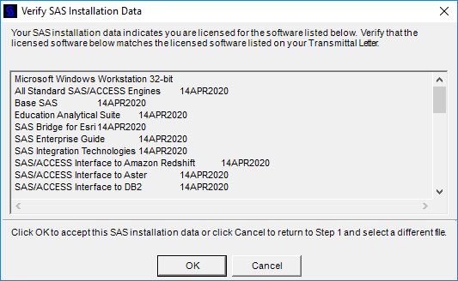

1. Click “OK” if the date looks right (if it is scheduled to expire sometime next year).
2. Now the application will ask you to verify that you want to renew[2]:

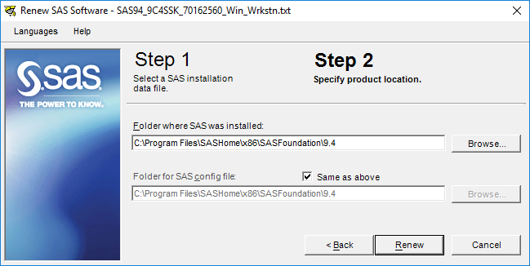

1. Click the “Renew” button.
2. Now release the breath you have been holding since **Step #1**. You were successfully able to renew your SAS license in one single breath, or your coworkers are currently trying to resuscitate you after you fainted in one of the middle steps. Either way, you no longer have to hold your breath for IT to renew your SAS license anymore.

1. Note the year at the end. It will vary depending on the year you are renewing for.
2. *HINT:* You do. It is why you are doing all of this.